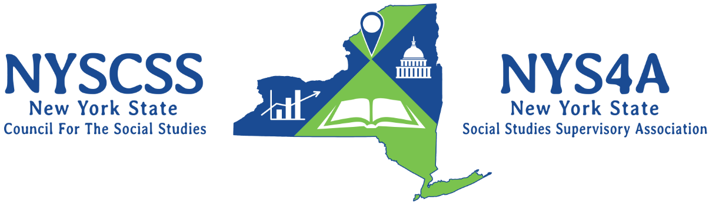
NYSCSS Awards Nomination Form

Awards Selection
For which award are you nominating an individual? (please check one)
☐Outstanding Social Studies Classroom Teacher Award (Elementary)
☐Outstanding Social Studies Classroom Teacher Award (Middle School)
☐Outstanding Social Studies Classroom Teacher Award (High School)
☐Distinguished Social Studies Educator Award
☐John Roy Continuing Social Studies Service Award
☐Susan Wasserman Young Professional Memorial Award
☐Benita Jaworsky Outstanding College Educator Memorial Award

Nominee Information
REQUIRED NOMINEE INFORMATION:
Nominee Name:
Nominee email:
Nominee Phone Number:
School District and Building:
Current Position:

Is the nominee a member of NYSCSS or NYS4A? |  | Yes |  | No |  | Both
Is the nominee a member of a Local Council? |  | Yes |  | No |  | Both
If member of a Local Council, which Council?

Nominator Information
REQUIRED NOMINATOR INFORMATION
Nominator Name:
Nominator email:
Nominator Phone Number:
Nominator Relationship to Nominee:

Please write a 250-500 word rationale which states why the nominee should be considered for this award. Information about how the nominee fits the specific awards criteria must be address.

Professional References
In addition to the nominator’s recommendation, at least one additional reference or letter of support for the nominee is required. This recommendation must be made by a person with a supervisory relationship to the nominee. Please attach the letter of reference to this nomination form and include the appropriate information below.

REQUIRED REFERENCE ONE:
Reference Name:
Reference email:
Reference Phone Number:
School District and Building:
Relationship to Nominee

REQUIRED REFERENCE TWO:
Reference Name:
Reference email:
Reference Phone Number:
School District and Building:
Relationship to Nominee

Thank you for submitting this award nomination! Please be sure to submit this form along with the appropriate letters of support to our Awards Committee Co-Chairs by Thursday, January 9. Completed forms and materials should be submitted electronically to either:
- Mary Duffin: mduffin2@verizon.net
- David Babikian: dbabikia@nscsd.org

